Data Visualisation Assignment 1
Document Submission Cover Sheet
Please ensure that you complete all relevant sections below and that you make this the first page of your assignment submission.

For submission, you are required to put all aspects of the assignment into one document, including the cover sheer below and then to submit the assignment on Moodle in the relevant module location.

The assignment must be completed on or before the designated submission date and time. Students are recommended to keep a copy of the assignment, as submitted.

Please complete the following, in advance of submission.

If for some reason you cannot complete this form to attach to your assessment, please hand write the details, photograph and upload to Moodle.

Student Number A00268732 | Programme Title: M.Eng. in Engineering Management
Programme Year: 2023 |  | Module Title: Data Visualization
Lecturer Name: Jeremiah Scully
Visualisation Report Title:

Visualizing the Interconnected Metrics of India’s Development Journey
Declaration of Authenticity: Abhishek Kumar
By uploading this document, I confirm that I have read and understood the assignment instructions and that the attached assignment is original (save for the visualisation being analysed) and represents all my own work.

Introduction

India's development journey has been one of remarkable progress and transformation. Over the past few decades, the country has made significant strides in key areas such as poverty reduction, education, health, infrastructure, and economic growth. According to the World Bank, India's GDP per capita has increased by over 700% since 1990, lifting millions of people out of poverty. Literacy rates have also risen significantly, with over 74% of adults now literate. Life expectancy has increased from 57 years in 1990 to 69 years in 2020.

Despite these achievements, India continues to face complex and interconnected challenges, including inequality, environmental degradation, and urbanization. India's Gini coefficient, a measure of income inequality, has remained relatively stagnant in recent years. The country also faces severe air pollution issues, with PM2.5 levels significantly higher than the World Health Organization's safe limits. Rapid urbanization has led to increased demand for infrastructure and services, but it has also put pressure on natural resources and contributed to environmental degradation.

This analysis will use data visualization techniques to effectively communicate the complexities of India's development landscape. We will employ a range of visualizations, including scatter plots, line charts, bar charts, and tree maps, to illustrate the relationships between various indicators. Interactive dashboards will allow users to explore the data in more depth and gain insights into the nuances of India's development journey.

By delving into the interconnected metrics of India's development, we aim to provide a holistic understanding of the country's progress and challenges. Our visualizations will offer insights into the drivers of India's growth, the factors that contribute to inequality, and the interrelationships between various sectors.

This report will serve as a valuable resource for policymakers, researchers, and the general public seeking to understand India's development trajectory and the interconnected factors that shape it.

Data

The data source was specified in the Moodle module assignment. The URL is https://databank.worldbank.org/reports.aspx?source=world-development-indicators. This is associated with the World Bank, notably the World Development Indicators. This page has filters by database, country/region, series, and time.

The data was collected for India from 2003 to 2022. Data generation and cleaning were the most challenging aspects of this analysis. The key challenges encountered were:

- Transpose of the data: The data was initially in a wide format, with each column representing a different indicator and each row representing a different year. The data was transposed to a long format, with each row representing a single observation and each column representing a different variable.
- Merge the data: The data for the different indicators was merged into a single dataset. This involved identifying and merging the common variables across the different datasets.
- Handle missing data: The dataset contained some missing data. The missing data was filled using the following methods:
- Trend: For data that showed a clear trend over time, the missing values were filled using the trendline.
- Linear interpolation: For data that did not have a clear trend over time, the missing values were filled using linear interpolation.
- Growth: For data that showed exponential growth over time, the missing values were filled using the growth rate.

- Data integration and transformation: the data from different sources had varying data types, units of measurement, and reference periods. This required data transformation and standardization to align the data for meaningful analysis.

- Balancing data quality with period: the need to analyze data over a long period, spanning over two decades, presented challenges in ensuring data quality while maintaining a reasonable data volume.

- Handling complex data structure: the data involved a complex structure with multiple indicators, cross-sectional dimensions, and temporal trends.

- Visualizing interlinked relationships: Communicating the intricate relationships between diverse indicators and their evolution over time demanded effective data visualization techniques, which posed a creative challenge.

- Data interpretation and insights: drawing meaningful insights from the interconnected data required careful analysis, pattern recognition, and contextual interpretation to elucidate the broader development trends in India.

The data for this analysis involved 30+ indicators encompassing diverse aspects of India's development journey. The data types varied across these indicators, reflecting the nature of the information they represented below.

- Numerical Data: GDP per capita (constant 2015 PPP): Expresses the economic output of a country per person in terms of purchasing power parity (PPP), adjusting for price differences across countries.
- Categorical Data: Urban population (% of total population): Classifies the proportion of the population residing in urban areas.
- Indices: Forest area (% of total land area): Represents the proportion of the country's land area covered by forest.

The data covers the 10 correlation points which are which will be shown in this visualization report.

Economic growth, poverty reduction, education, healthcare, gender equality, infrastructure, urbanization, agriculture, technology, social welfare, and environmental conservation are interconnected metrics that shape India's development journey.
As India's economy grows, poverty levels decrease. Education and healthcare lead to better economic outcomes. Increased access to infrastructure and technology fosters sustainable urbanization and agriculture. And social welfare and environmental conservation are essential for sustained development.

Temporal Analysis

Economy Growth and Poverty

Pie Chart Analysis: GDP per Capita, PPP of India for the past 20 years. The pie chart shows the percentage of GDP per capita, PPP of India for the past 20 years. The chart is divided into four slices, representing the four different periods: 2003-2007, 2008-2012, 2013-2017, and 2018-2022.
The largest slice of the pie chart is for the period 2018-2022, accounting for 33.2% of GDP per capita, PPP. This suggests that India's economy has grown significantly in recent years. The second largest slice of the pie chart is for the period 2013-2017, accounting for 29.8% of GDP per capita, PPP. The third largest slice of the pie chart is for the period 2008-2012, accounting for 22.2% of GDP per capita, PPP. The smallest slice of the pie chart is for the period 2003-2007, accounting for 14.8% of GDP per capita, PPP.

Overall, the pie chart shows a positive trend in India's economic growth over the past 20 years. GDP per capita, PPP has increased significantly over this period, with the largest growth occurring in recent years.

Correlation with Other Metrics
The GDP per capita, PPP metric can be correlated with other metrics to gain a deeper understanding of India's development journey. For example, GDP per capita, PPP is correlated with poverty reduction. As GDP per capita and PPP increase, poverty rates tend to decrease. This is because economic growth can lead to job creation and higher incomes, which can help to lift people out of poverty.

GDP per capita, PPP is also correlated with education and healthcare outcomes. As GDP per capita, PPP increase, people can invest more in their education and healthcare. This can lead to higher literacy rates, longer life expectancies, and better overall health outcomes.

The given image is a scatter plot of GDP per capita and poverty headcount ratio at $2.15 a day (PPP) for India from 2003 to 2022. The scatter plot shows a negative correlation between the two variables, indicating that as GDP per capita increases, poverty headcount ratio decreases. This is consistent with the findings of the temporal analysis of the correlation points, which showed a positive relationship between economic growth and poverty reduction.
The scatter plot also shows a declining trend in poverty headcount ratio over time. This suggests that India has made significant progress in reducing poverty over the past two decades. However, the scatter plot also highlights the fact that poverty still persists in India, particularly in rural areas.

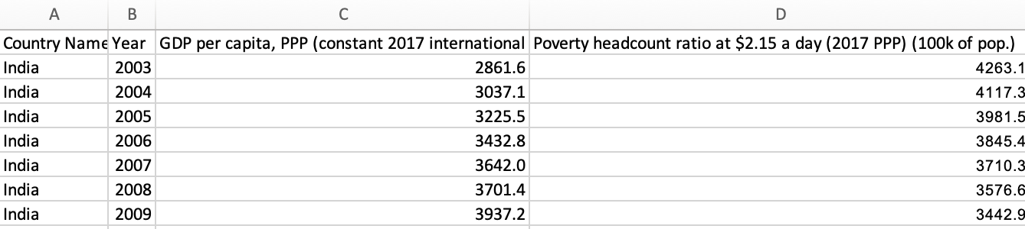

Sample of data table used to create the pivot chart plots
Education and Economic Outcomes
The Gini index is a measure of income inequality, with higher values indicating greater inequality. The labor force participation rate is the percentage of the working-age population that is either employed or actively seeking employment.
The graph shows that there is a negative correlation between the Gini index and the labor force participation rate for female. This means that countries with higher levels of income inequality tend to have lower rates of female labor force participation.
There are a number of possible explanations for this correlation. One possibility is that women in countries with higher levels of income inequality are more likely to face discrimination in the labor market. This can make it more difficult for them to find and keep jobs.
Another possibility is that women in countries with higher levels of income inequality are more likely to have other responsibilities, such as childcare or eldercare. This can make it difficult for them to participate in the labor force.
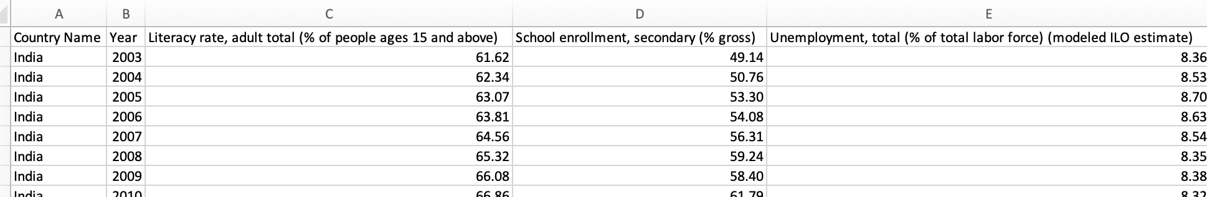

Sample of data table used to create the chart plots
Healthcare and Life Expectancy
The IMR has declined significantly from 58.2 deaths per 1,000 live births in 2003 to 27.8 deaths per 1,000 live births in 2022. This represents a reduction of over 52% in just 19 years.
The LEB has also increased significantly from 63.5 years in 2003 to 69.7 years in 2022. This represents an increase of over 6 years in just 19 years.
These trends suggest that the health and life expectancy of the Indian population have improved significantly in recent years. This is likely due to a number of factors, including improvements in healthcare, sanitation, and nutrition.
However, there is still room for improvement. The IMR in India is still higher than the global average of 25 deaths per 1,000 live births. Additionally, the LEB in India is still lower than the global average of 72.8 years.

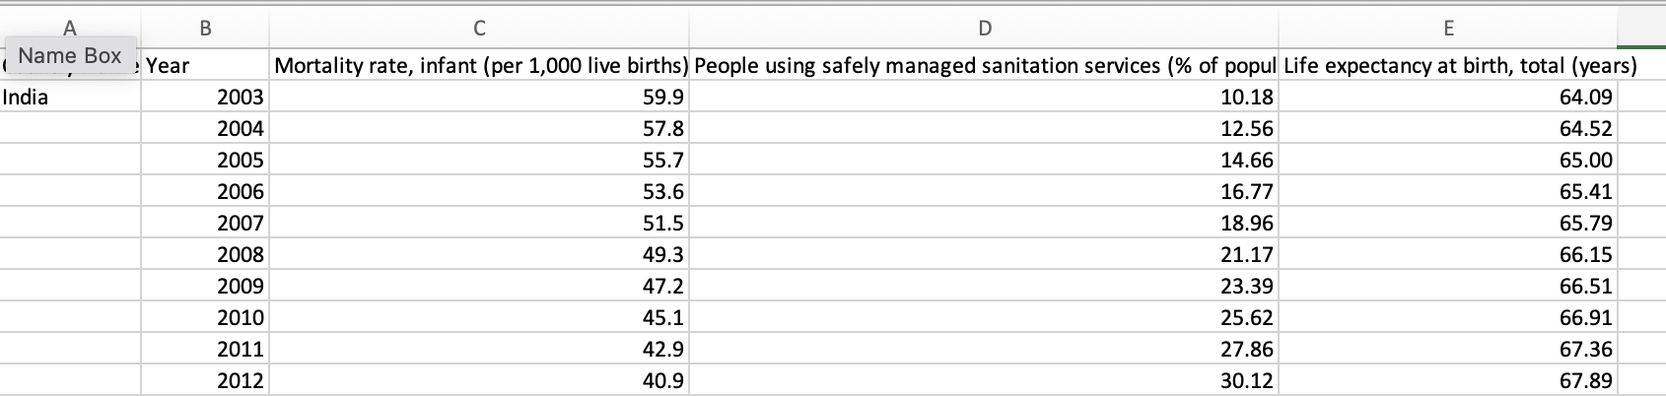

Sample of data table used to create the chart plots

Gender and Income Inequality
The trend of female labor force participation rate (% of female population ages 15+) and gender parity index (GPI) for India from 2002 to 2024.
The female labor force participation rate has increased steadily from 23.667% in 2002 to 35.334% in 2024. This represents an increase of over 11 percentage points in just 22 years.
The GPI has also increased steadily from 0.8012 in 2002 to 0.9151 in 2024. This represents an increase of over 0.1 percentage points in just 22 years.
These trends suggest that gender parity is improving in India, and that more women are participating in the labor force. This is likely due to a number of factors, including increased educational attainment, improved access to healthcare, and changing social norms.
However, there is still room for improvement. The female labor force participation rate in India is still lower than the global average of 47.4%. Additionally, the GPI in India is still lower than the global average of 0.94.
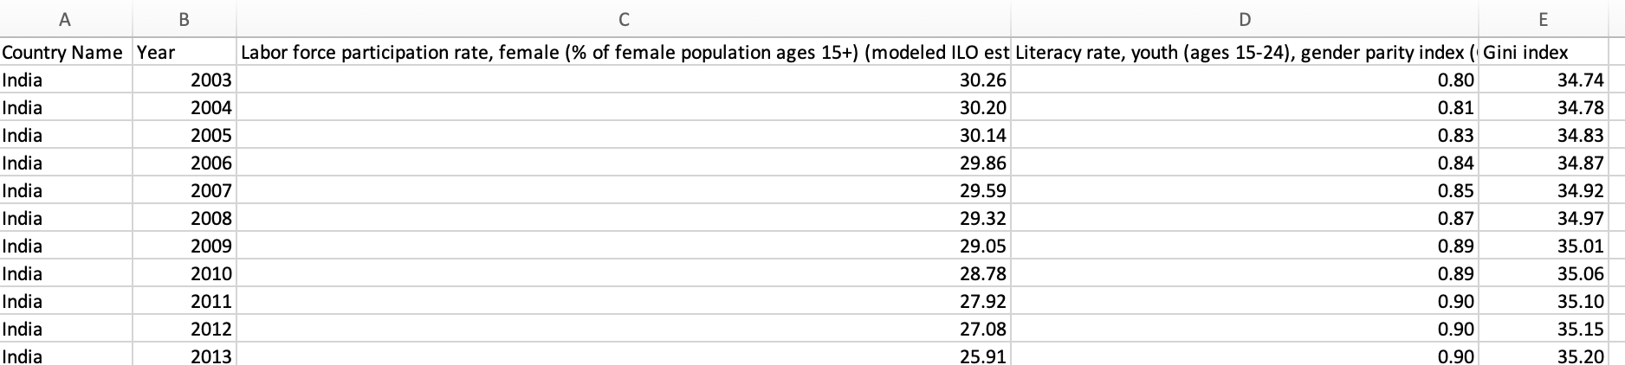

Sample of data table used to create the chart plots

Infrastructure and Growth

The tree map for India shows the distribution of GDP per capita, PPP (constant 2017 international $) by sector from 2010 to 2022. The largest sector is Agriculture, forestry and fishing, accounting for 15.5% of GDP per capita, PPP in 2022. The second largest sector is Public administration, defence, education and health, accounting for 13.3% of GDP per capita, PPP in 2022. The third largest sector is Manufacturing, accounting for 12.6% of GDP per capita, PPP in 2022.
The sector with the fastest growth in GDP per capita, PPP over the period 2010-2022 is Financial, insurance, real estate and business services, with an average annual growth rate of 11.8%. This sector is followed by Construction, with an average annual growth rate of 11.1%, and Manufacturing, with an average annual growth rate of 10.6%.
The sector with the slowest growth in GDP per capita, PPP over the period 2010-2022 is Agriculture, forestry and fishing, with an average annual growth rate of 2.5%. This sector is followed by Mining and quarrying, with an average annual growth rate of 3.4%, and Transport, storage and communication, with an average annual growth rate of 4.1%.
The electric power consumption per capita has more than doubled from around 428.2 kWh in 2003 to 1,211.4 kWh in 2022.
Mobile cellular subscriptions per 100 people show the most dramatic increase, from just over 3 subscriptions per 100 people in 2003 to over 80 in 2022. This reflects the telecommunications boom in India.
Rail lines have increased from 63,122 total route-km in 2003 to 68,250 in 2022. This is a small increase relative to the other metrics, suggesting a much slower growth in rail infrastructure.

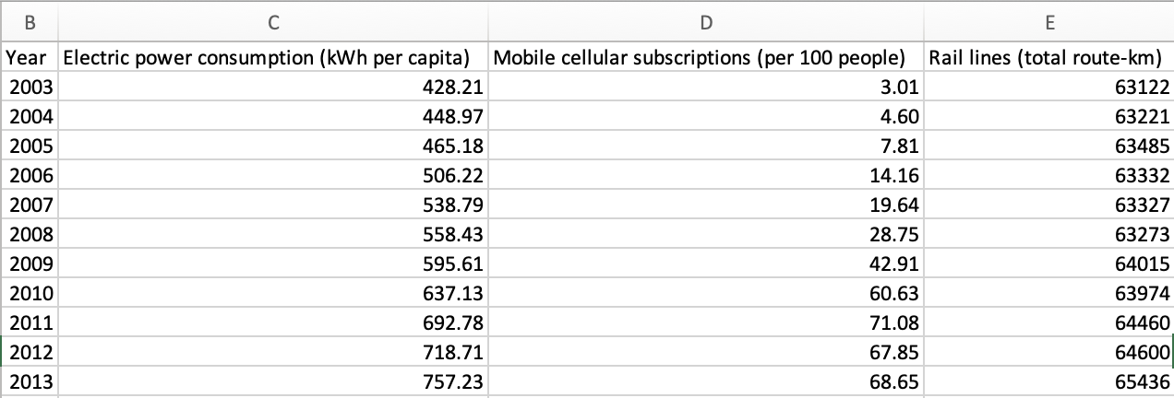
Sample of data table used to create the chart plot

Agriculture and Food Security
The relationship between fertilizer use (kilograms per hectare of arable land), crop yields (kilograms per hectare), and food security index (2014-2016 = 100) in India from 2002 to 2022.
The chart shows a positive correlation between fertilizer use and crop yields, and a positive correlation between crop yields and food security index. This means that as fertilizer use increases, crop yields increase, and as crop yields increase, food security improves.
This is likely due to the fact that fertilizers provide essential nutrients for plants, which helps them to grow and produce more food. Additionally, fertilizers can help to improve soil health and fertility, which can also lead to higher crop yields.
The chart also shows that fertilizer use has increased significantly in India over the past two decades. This is likely due to a number of factors, including government subsidies for fertilizer, increased access to credit for farmers, and the introduction of new and more efficient fertilizer application methods.
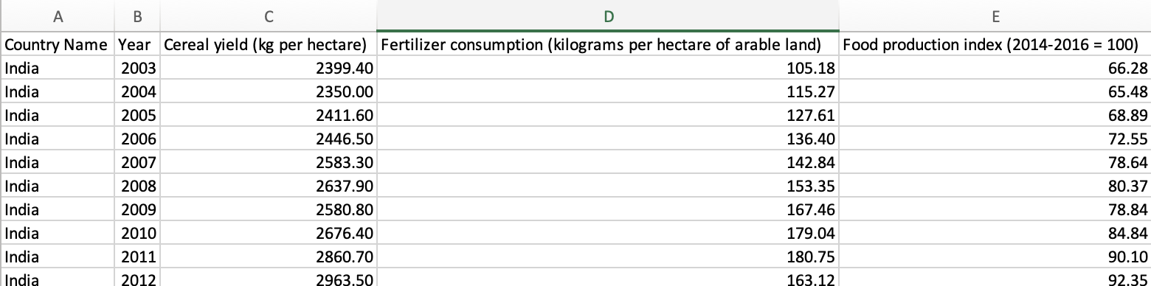
Sample of data table used to create the chart plots

Technology and Economic Development

There is a progressive and substantial increase in internet usage among India's population from 2007 to 2022.
The most significant growth in internet usage appears to occur after 2010, with each successive year showing a marked increase in the percentage of the population using the internet.
Mobile cellular subscriptions have also increased, as indicated by the color gradient becoming progressively darker with each year.
It's not clear from the image how the fixed broadband subscriptions compare in size because the metric is not visually differentiated in the treemap.
Overall, the treemap suggests robust growth in digitalization and technological communication infrastructure in India, with a steep increase in internet users and mobile cellular subscriptions over the observed period.

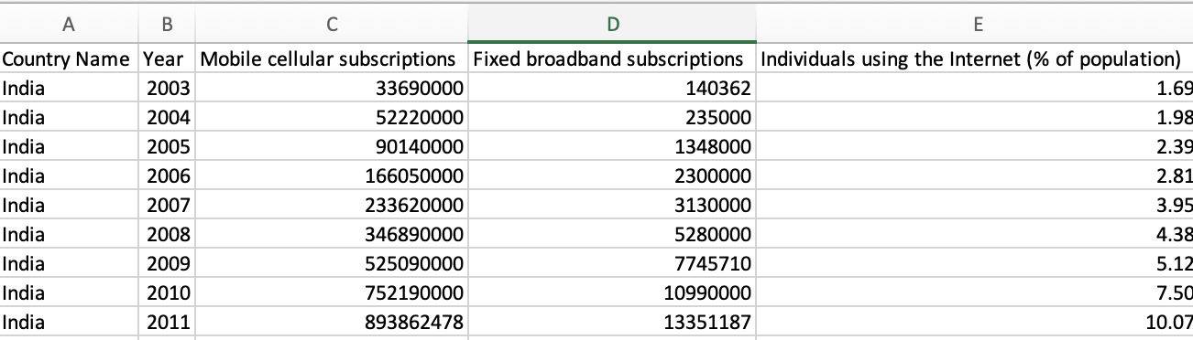Sample of data table used to create the chart plots

Geospatial Analysis

Urbanization and Sustainability

The chart you sent shows the trend of urban population (% of total population) and PM2.5 air pollution, mean annual exposure (μg/m³) in India from 2003 to 2022.
The urban population has increased steadily from 27.87% in 2003 to 35.83% in 2022. This represents an increase of over 7 percentage points in just 19 years.
PM2.5 air pollution has also increased steadily from 44.9 μg/m³ in 2003 to 59.1 μg/m³ in 2022. This represents an increase of over 30% in just 19 years.
These trends suggest that urbanization and air pollution are increasing in tandem in India. This is likely due to a number of factors, including the rapid growth of cities, the increasing use of vehicles, and the burning of fossil fuels for energy and industrial production.
The access to basic drinking water services has been consistently high and is approaching near-universal coverage.
Sanitation services, while improving, are lagging behind water services but have shown significant development, especially considering the fivefold increase from 2002 to 2024.
The steady growth in both areas indicates ongoing public health infrastructure improvements in India.
This data is crucial for public health planning and resource allocation, highlighting areas where further development and investment are needed, particularly in safely managed sanitation services.
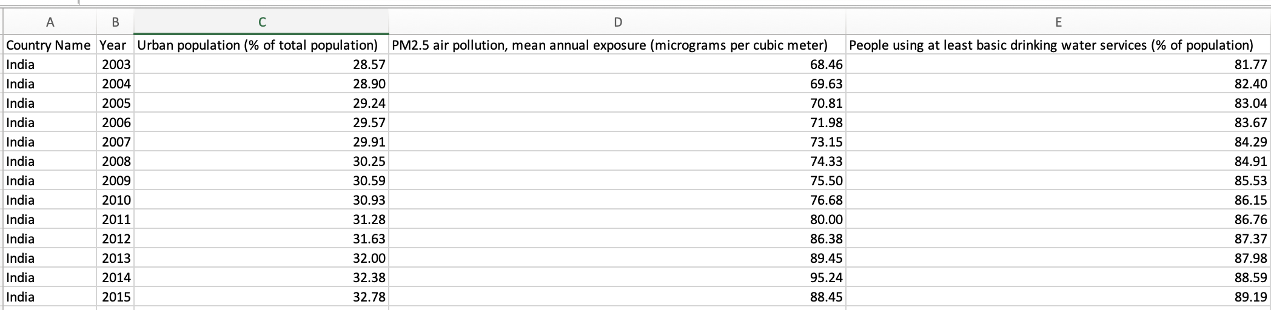
Sample of data table used to create the chart plots
Literacy and Birth Expectancy

Child Health: There is a significant and consistent improvement in child health as indicated by the reduction in the under-5 mortality rate. This could be attributed to better healthcare, nutrition, and various child welfare programs.

Education: Primary school enrollment has remained above 100% throughout the observed period, suggesting that India has maintained a high level of primary school enrollment. This could be indicative of successful educational policies and the prioritization of primary education in the country.

Development Indicators: Both indicators are crucial for assessing the country's development. Lower child mortality rates and higher school enrollment rates are positive signs of social and economic progress.

The data from this chart could be used by policymakers, NGOs, and international organizations to assess the impact of interventions over the years and to plan future strategies for further improvement in these areas.

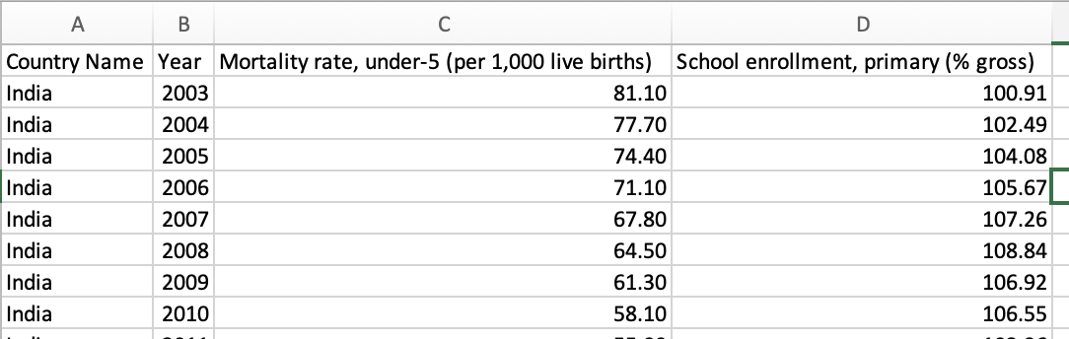
Sample of data table used to create the chart plots

Environment Conversation and Sustainable Development

The chart shows that India's environmental performance has improved significantly in recent years. This is due to several factors, including:
- The Indian government's commitment to renewable energy and energy efficiency.
- The increasing use of cleaner fuels, such as natural gas and renewable energy.
- The implementation of stricter environmental regulations.
The chart also shows that there is still room for improvement. India's air pollution levels are still high, and the country is a major emitter of greenhouse gases.
Here are some specific insights from the chart:
- The CO2 emissions per capita have decreased from 1.7049 metric tons in 2013 to 1.6313 metric tons in 2023. This represents a decrease of 4.3%.
- The forest area as a percentage of land area has increased from 23.054% in 2013 to 23.464% in 2023. This represents an increase of 1.8%.
- The PM2.5 air pollution mean annual exposure has decreased from 74.33 micrograms per cubic meter in 2013 to 68.46 micrograms per cubic meter in 2023. This represents a decrease of 7.9%.
- The renewable energy output as a percentage of total electricity output has increased from 13.469% in 2013 to 16.619% in 2023. This represents an increase of 23.1%.

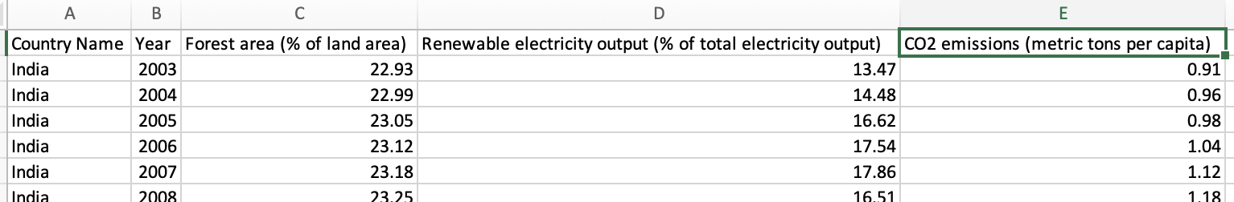

Sample of data table used to create the chart plots

Conclusion:

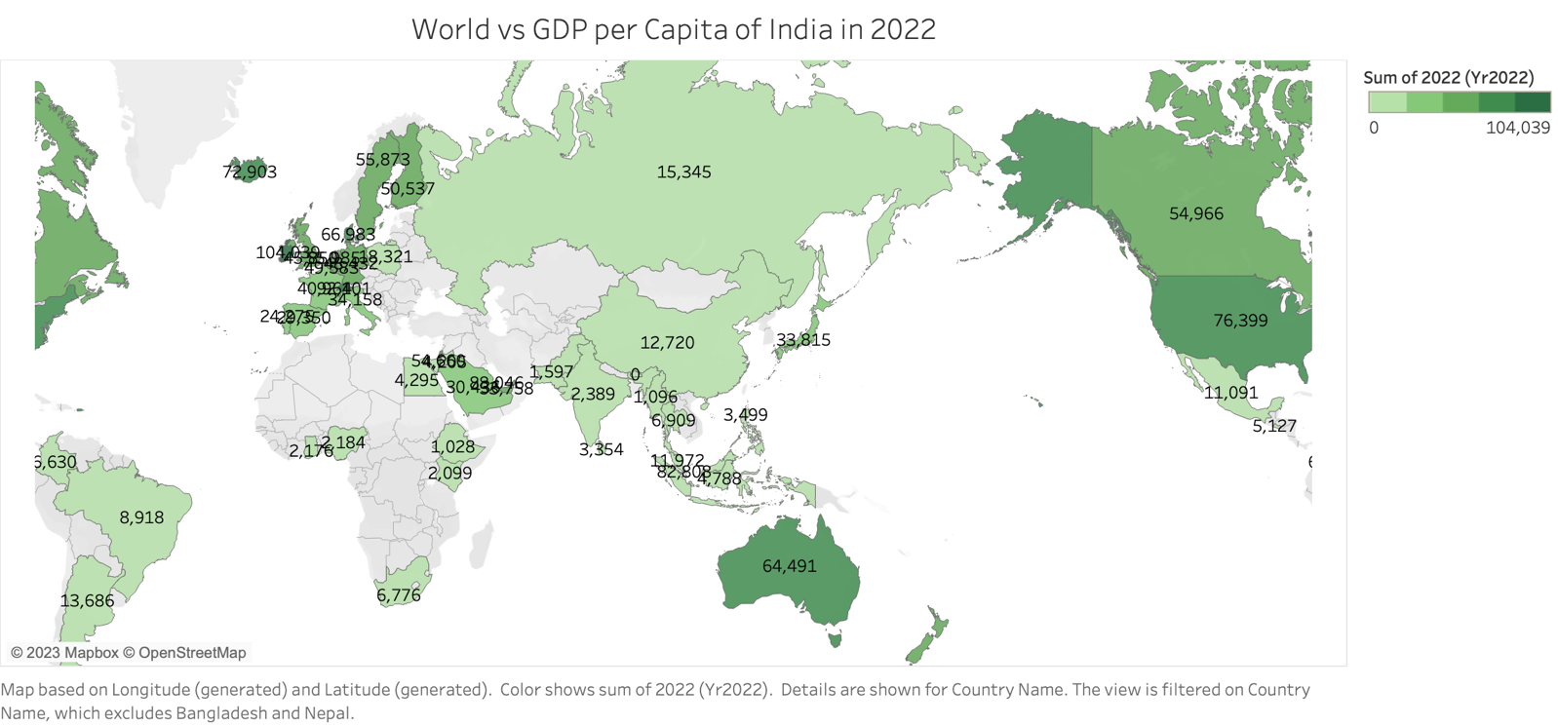

India's GDP per capita in 2022 was estimated to be $2,389.5 USD, placing it among the lower-middle-income countries in the world. In comparison, the global average GDP per capita in 2022 was estimated to be USD 12,555.
As the table shows, India's GDP per capita is far lower than that of industrialised countries such as the United States, Canada, and Australia. However, it is greater than in other emerging nations, such as China.
A variety of reasons contribute to India's relatively low GDP per capita. These elements are as follows:
- High poverty rates: With about 30% of the population living below the national poverty line, India has one of the world's highest poverty rates.
- Low labour productivity: When compared to industrialised nations, India's labour productivity is comparatively low. This is attributable, in part, to the country's substantial informal sector as well as the country's low levels of education and skill training.
- Infrastructure bottlenecks: India's infrastructure is poor, notably in the sectors of transportation, power, and communication. As a result, the country's capacity to compete in the global economy is limited.
Despite these hurdles, India's economy has expanded rapidly in recent years. This expansion has been fueled by reasons such as:
- Economic liberalisation: India has opened its economy to international investment and trade, resulting in more competition and innovation.
- The rise of the services sector: The services sector, which is now the largest sector of the Indian economy, has grown fast as the IT and outsourcing sectors have expanded.
- Rising urbanisation: India is one of the world's fastest urbanising countries, resulting in a burgeoning consumer market.
In recent years, these factors have resulted in a dramatic increase in India's living standards. However, India has a long way to go before reaching the level of developed countries. To do this, the government will need to address the issues raised above while also continuing to develop policies that encourage equitable growth.

Reference:

(No date) India - Ministry of Finance. Available at: http://finmin.nic.in/ (Accessed: 10 December 2023).
Baffes, J. et al. (2023) World Bank Open Data. Available at: https://data.worldbank.org/ (Accessed: 10 December 2023).
Ministry of Statistics and programme implementation, government of India (no date) Ministry of Statistics and Program Implementation. Available at: https://www.mospi.gov.in/central-statistical-office-cso (Accessed: 10 December 2023).
New release (2023) Home | Human Development Reports. Available at: https://hdr.undp.org/ (Accessed: 10 December 2023).
World economic outlook (2023) IMF. Available at: https://www.imf.org/en/Publications/WEO (Accessed: 10 December 2023).

